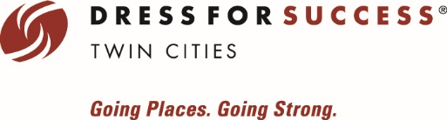
Company Logo

Donate Your Clothes!
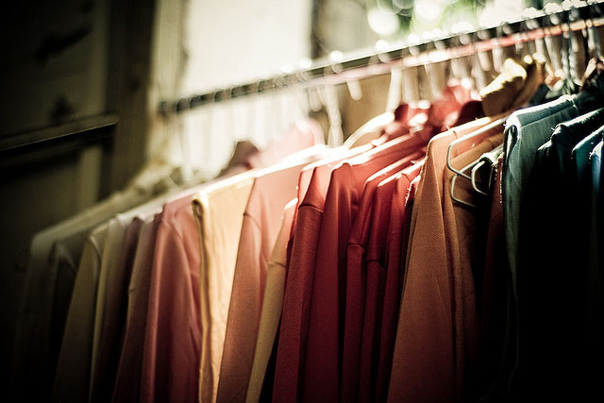
Bring your gently used Women’s Professional Clothing to donate to Dress for Success Twin Cities, from (Date) to (Date). Please place your donation next to (location).
No clothes to donate? Consider making a monetary donation instead!
Accepted Items:
- Full Suits
- Blazers
- Pants
- Skirts
- Blouses
- Sweaters
- Handbags & Briefcases
- Professional Shoes (heels & flats)
- New or unused bras, underwear, shapewear, hosiery and cosmetics
- Professional Maternity wear
- Professional Jewelry or Watches
All items should be gently used or new, in current ready-to-wear condition.

Dress for Success Twin Cities is a non-profit organization that promotes economic independence for disadvantaged women by providing professional attire, support, and career development tools to help women thrive in work and life.

