<INSERT YOUR LOGO HERE>

WE ARE HOSTING A DONATION DRIVE!

Bring your gently used women's professional clothing and help to empower women in our community!

ACCEPTED ITEMS
Donate clothing of all sizes (00-5X+) Business professional suits Professional separates including blouses, slacks, skirts, dresses, blazers, sweaters, and jackets
Casual separates including shirts, jeans, dresses, sweaters, and coats Professional shoes (flats, heels, boots) Scarves
Handbags Jewelry Scrubs
Professional maternity apparel Non-slip footwear
Hats, gloves, and winter jackets (in winter months)

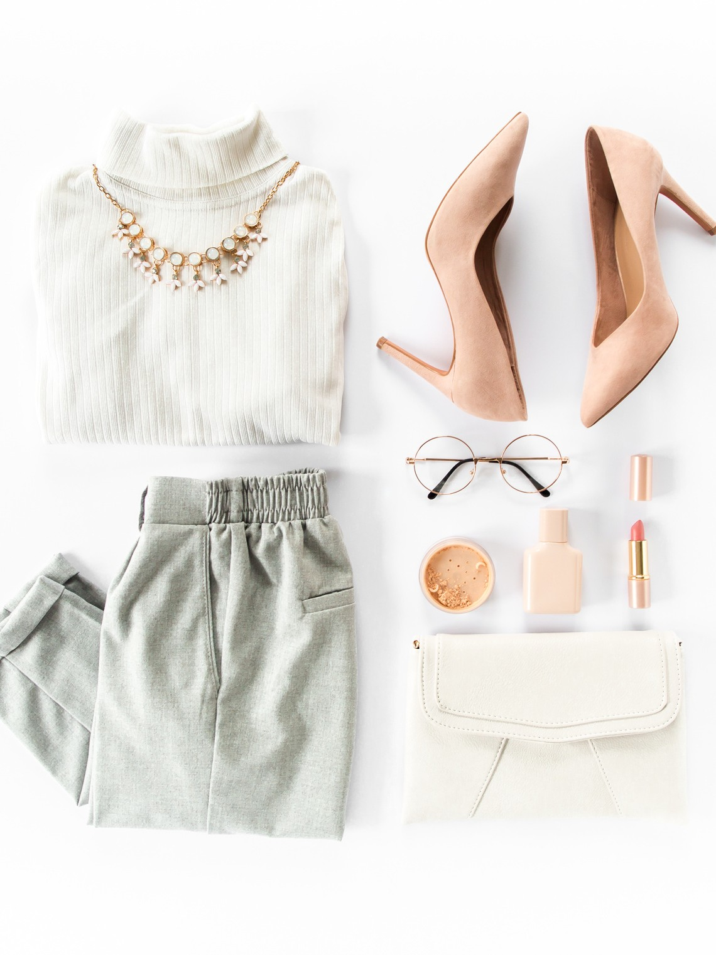

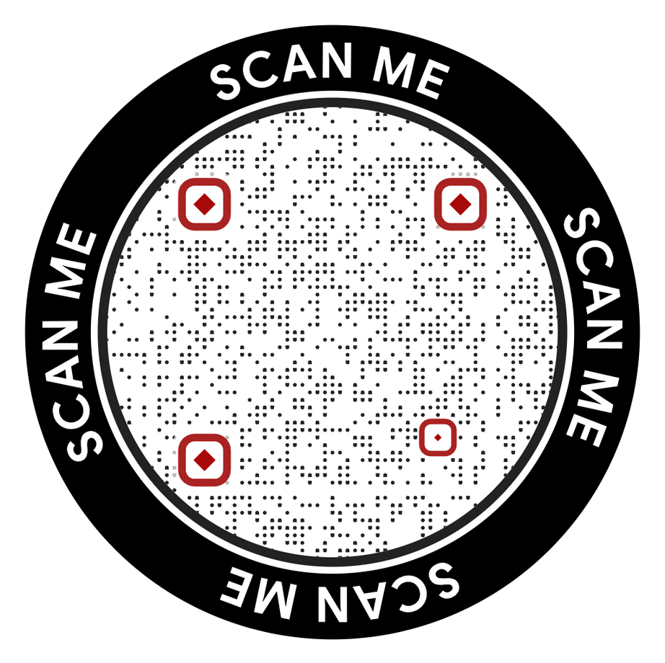
NEED A DONATION RECEIPT?

MAKE AN
EVEN GREATER IMPACT!
Make a donation and support success.

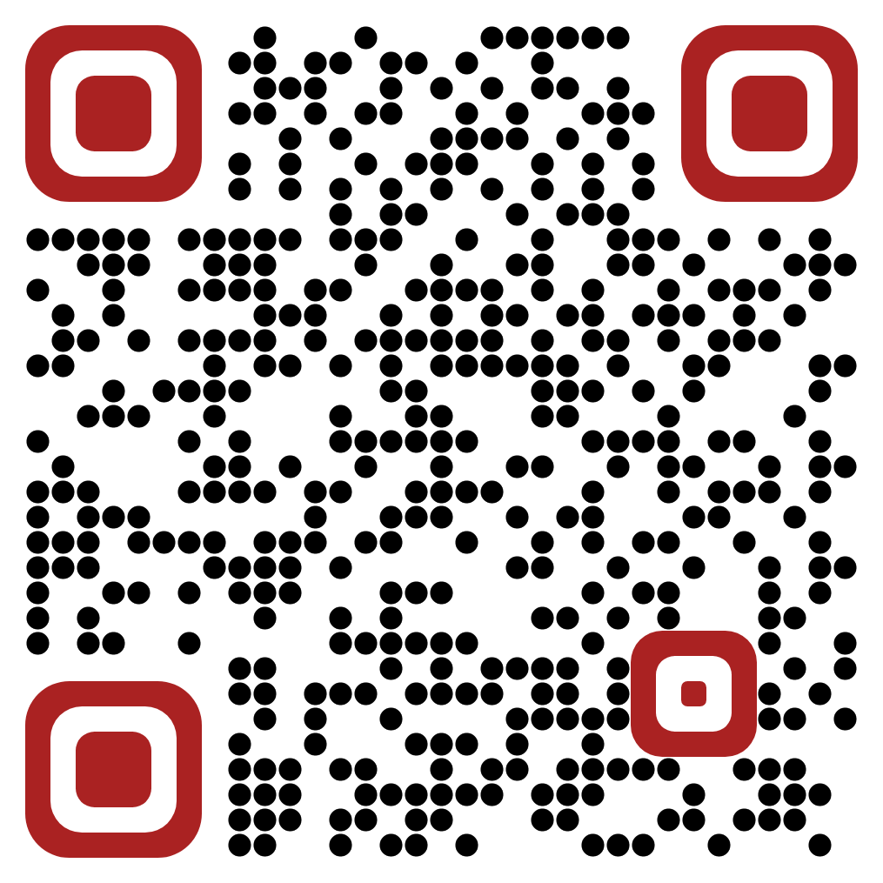
SCAN TO
DONATE

